ES Lab Manual

Fontys ICT  
Version 1.0; July 2019  
Authors: Filip Georgiev, Jaap Geurts

Table of Contents

1. Week 2 1

1.1. Exercise 2.1: Blinking LED 1

1.2. Exercise 2.2: Blink a LED on the Rich Shield 3

1.3. Exercise 2.3: Blink led and change to on 3

1.4. Exercise 2.4: Button and LED 3

1.5. Exercise 2.4: Two buttons toggling a LED 4

1.6. Exercise 2.5: Toggle a LED with one button 4

# 

# Week 2

This week you will use and modify the examples, that you installed with the libraries for the Rich Shield last week. For information what the Rich Shield can do watch <https://www.youtube.com/watch?v=J9RKdApnJA4>.

## Exercise 2.1: Blinking LED

Goal: Blink a LED to show that the device is busy.

A blinking led often indicates that the device is busy or an error has occurred. E.g a coffee machine is blinking while the hot water is being boiled. A LED is blinking when a video is recording etc... In this assignment we’re going to blink a LED on the Arduino and on Rich Shield.

* First unplug the Arduino from the USB port.
* Remove the Rich Shield.
* Reconnect the Arduino
* Open the Blink example that comes with the arduino IDE. (see below)
* Verify the program and upload run it.

**Open the Blink example:**

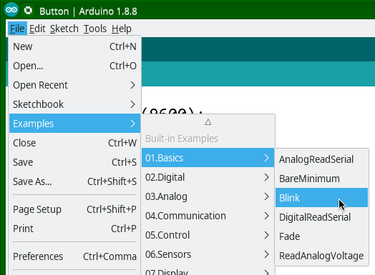

This example makes use of the built in LED in the Arduino

The led is placed here:

Position of the LED

If you run the program that LED will blink.

## Exercise 2.2: Blink a LED on the Rich Shield

Goal: Change the program in such a way that one of the LEDs on the Rich Shield blinks instead.

Download the Rich Shield documentation and Rich Shield.zip file from canvas. Go to <https://portal.fhict.nl/es/SitePages/Home.aspx> - > ES -> RichShieldDocumentation.pdf(example)

Install the rich shield library from the zip file by going to Sketch -> Include Library -> Add .ZIP library and choosing the zip file from the folder in which you downloaded it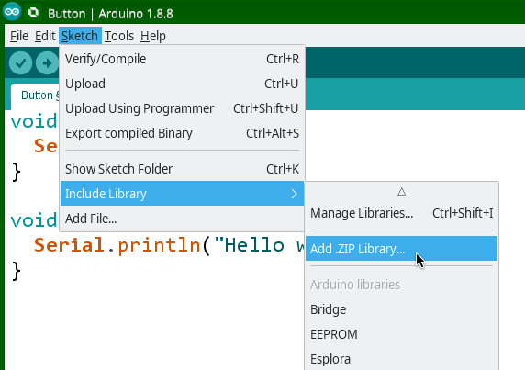

Open the RunLed example. File -> Examples -> RichShield -> Basic -> RunLed

Compare the first example for Arduino with the example of the Rich Shield to and try to understand some of the differences.

## Exercise 2.3: Reverse the order

Goal: Change the blinking direction of the leds

Consider the RunLed example. Now change the program in such a way that the LEDs light up in the reverse direction (right to left)

## Exercise 2.4: Blink led and change to on

Goal: blink a led and change to always on after 10 times blinking

Consider a coffee machine. When the machine is switched on the water is cold and it will starting boiling. While boiling a LED blinks to indicate what the machine is doing. When the water has reached the desired temperature the LED stops blinking and lights up continuously.

Write a program that implements the required functionality. Make sure it blinks exactly 10 times and switches on at the 11th time.

## Exercise 2.4: Button and LED

In this assignment you have to make it so that when you click one of the two buttons on the Rich Shield the LED will light up. For this to work you must follow the same steps as the previous assignment, but also define a button. First of all open the L02_Key_Led example:

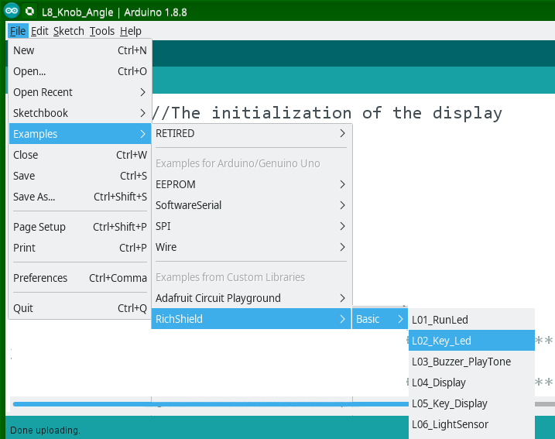

Run the program to see what it does.

Analyse the program and draw a flowchart of the program.

## Exercise 2.4: Two buttons toggling a LED

Now copy the previous assignment and try to add a second button to it. This time, the first button should turn the LED on, while the second button should turn it off. This means that you will have to have read two keys and read their state. Note that changing the state of the first button should not turn the LED off.

## Exercise 2.5: Toggle a LED with one button

Let’s make it a little bit harder. We want you to create the same functionality as the previous assignment but only using one button. Give it a try!

if(Assignment == Done) {

Serial.println(“Good Job!”);

} else {

try the Examples -> Digital -> StateChangedDetection ;

}

Now you have a simple toggling program. But are you sure that it works correctly? Do you see some strange behaviour? Click it multiple times, hold it down a little bit. Can you explain this behaviour? Next week you will find out why this is happening.